**Project Report Template**

**Title of Project:** Donation optimizer   
**Name of the Innovator:** Shubhashree.k  
**Start Date:** 16-10-2025

**End Date: 04-09-2025**

***Day 1: Empathise & Define***

*Step 1: Understanding the Need*

* Which problem am I trying to solve?

I am trying to solve the problem of **inefficient and misaligned charitable donations** faced by **individual donors who want to make a meaningful impact but lack the information or tools to do so effectively**.

Many donors are unsure **which causes are most urgent**, **which organizations are most effective**, or **how to distribute their contributions for maximum impact**.

* Who is affected by this problem?
* How did I find out about this? [Select whichever is applicable]
* Interviews
* Observation
* Online Research
* AI Tools

*Step 2: What is the problem?*

**Individual donors and charitable givers** need a way to **optimize their donations to maximize social impact** because **they currently face challenges in identifying the most effective causes and organizations to donate to, lack transparent data on charity performance, and struggle to distribute their funds in a way that truly makes a difference.**

Why is this problem important to solve?

**Optimizing donations helps ensure every dollar creates the biggest impact, builds donor trust, reduces wasted funds, and encourages more giving. It makes charitable giving smarter and more effective, ultimately driving better solutions for important social issues.**

**Take-home task**

Ask 2-3 people what they think about the project:

**Teachers**

I think the Donation Optimizer is a great idea, especially for encouraging thoughtful giving. It should be simple to use for busy educators. Features like goal-setting and progress tracking would be helpful. I would suggest it to colleagues who want to make a difference with donations.

**Students**

The Donation Optimizer sounds interesting and useful for making donations count. It needs to be really user-friendly so anyone can use it quickly. I’d want features that explain how donations help different causes. I’d consider using it if it’s easy and makes donating more meaningful.

**AI Tools Used:**

**1. Meta MGX**

* **Used as a no-code development tool to design and deploy the *Donation optimizer* .**
* **It helps create interactive workflows, user interfaces, and logic without programming.**
* **Ideal for building features like user registration, location-based data, and skill modules.**

**2. ChatGPT**

* **Used for idea generation, content structuring, and chatbot conversation design.**
* **Helped in framing the AI-powered virtual assistant’s responses for guiding students.**
* **Also useful for generating career recommendations, FAQs, and improving user interaction flow.**

***Day 2: Ideate***

*Step 3: Brainstorming solutions*

* List **at least 5 different solutions** (wild or realistic):
* **User-Friendly Interface:**  
  Make the tool simple and intuitive so anyone—parents, teachers, or students—can easily use it without confusion.
* **Personalized Donation Recommendations:**  
  Offer tailored suggestions based on users’ interests and preferred causes to make donations more meaningful.
* **Impact Tracking Dashboard:**  
  Show clear updates on how donations are being used to build trust and keep users motivated.
* **Goal Setting & Reminders:**  
  Help users set donation goals and send reminders to encourage consistent giving over time.
* **Donation History & Tax Records:**  
  Keep a detailed record of donations with downloadable receipts to simplify tax filing and personal tracking.

*Step 4: My favourite solution:*

***My favourite solution for the Donation Optimizer is the Impact Tracking Dashboard.*** *This feature is crucial because it provides donors with clear and transparent information about how their donations are being utilized and the positive impact they create. By allowing users to see real results, it fosters trust and motivation, encouraging them to continue supporting causes they care about. Ultimately, this makes the Donation Optimizer more effective and engaging..*

*Step 5: Why am I choosing this solution?*

*I am choosing the Impact Tracking Dashboard for the Donation Optimizer because it helps donors see the real difference their contributions make. This transparency builds trust and motivates people to give more consistently. By showing the impact clearly, the tool becomes more engaging.*

**AI Tools for Step 3–5**

**1. Meta MGX**

* Used to **design and build the Donation optimizer app** without coding.
* Helps create the **AI assistant, skill modules, and location-based features**.

**2. ChatGPT**

* Helps **brainstorm solutions** and generate ideas for career guidance features.
* Can **structure conversations** for the AI virtual assistant.
* Assists in writing content for skill modules, FAQs, and recommendations.

*AI Tools you can use for the take-home task:*

**Canva AI/CoPilot AI/Meta AI:** Use these mobile-based tools to generate images for the solution they want to design

***Day 3: Prototype & Test***

*Step 6: Prototype – Building my first version*

What will my solution look like?

My solution will be a clean, easy-to-navigate Impact Tracking Dashboard within the Donation Optimizer. The dashboard will include:

* **Summary of Donations**: A clear overview showing total donations made by the user.
* **Impact Metrics**: Visual elements like charts or progress bars that display how donations have helped (e.g., number of people helped, projects funded).
* **Stories & Updates**: Short, engaging updates or testimonials from charities showing the real-world effect of donations.
* **Donation History**: A timeline or list of past donations with details.
* **Call-to-Action**: Buttons to encourage users to donate again or share their impact on social media.

**The design will focus on simplicity and transparency, making it easy for users of all ages (parents, teachers, students) to understand the value of their giving.**

**Design Style:**

* keep the design simple and easy to use for everyone.
* Use calm, friendly colors like blue and green to feel trustworthy and relaxing.
* Choose clear, easy-to-read fonts—nothing too fancy**.**

**Prototype Tools:**

Built using **Meta MGX**, no coding required, with all features **interactive and testable**.

What AI tools will I need to build this?

**AI Tools Needed to Build Donation optimizer**

1. **Meta MGX**
   * No-code platform to **design and deploy the app**.
   * Allows building **interactive screens, chat interfaces, and skill modules** without coding.
2. **ChatGPT (or similar LLMs)**
   * To **generate content, conversation flows, and career guidance responses**.
   * Can help **personalize recommendations** for users based on their profile and location.
3. **AI Chatbot Design References**
   * To **structure conversation logic** and handle user queries effectively.
4. **AI Recommendation Tools** *(Optional but useful)*
   * For **matching students with careers, scholarships, and nearby opportunities**.
   * Could use **ML-based ranking algorithms** or **existing AI APIs** for personalization.
5. **AI Data Analysis Tools** *(Optional for insights)*
   * **Python AI libraries (Pandas, Scikit-learn)** or **AI analytics platforms**
   * To analyze user interactions and improve recommendations over time.

What AI tools I finally selected to build this solution?

1. **Chat GPT**
2. **Metamgx**

**< Build The Innovation>**

**<DASHBOAD OF THE TOOL>**

**Tool Link:**  https://mgx-u6kh9k37h5i.mgx.world

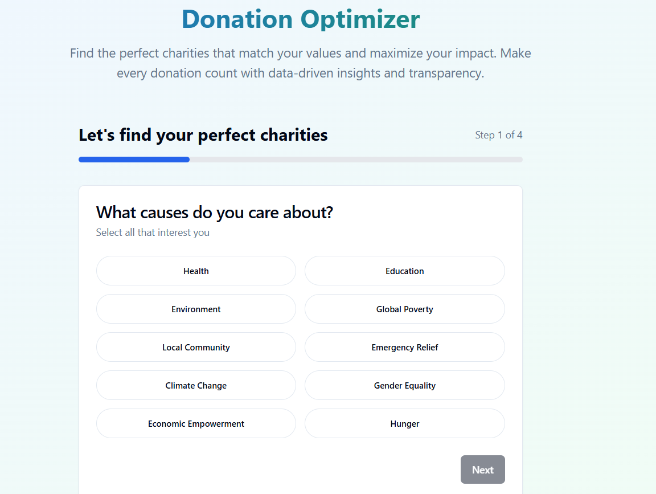

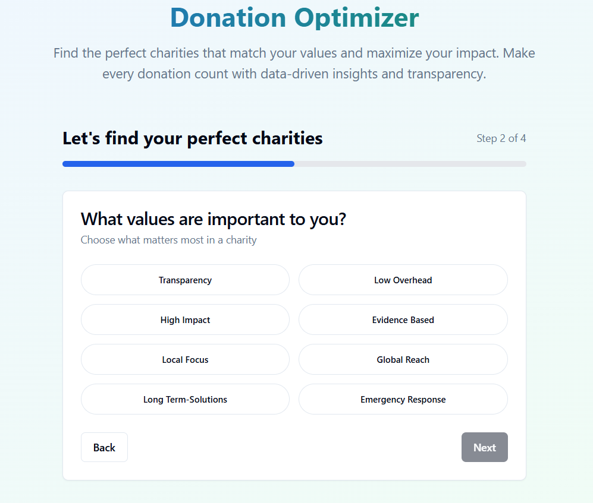

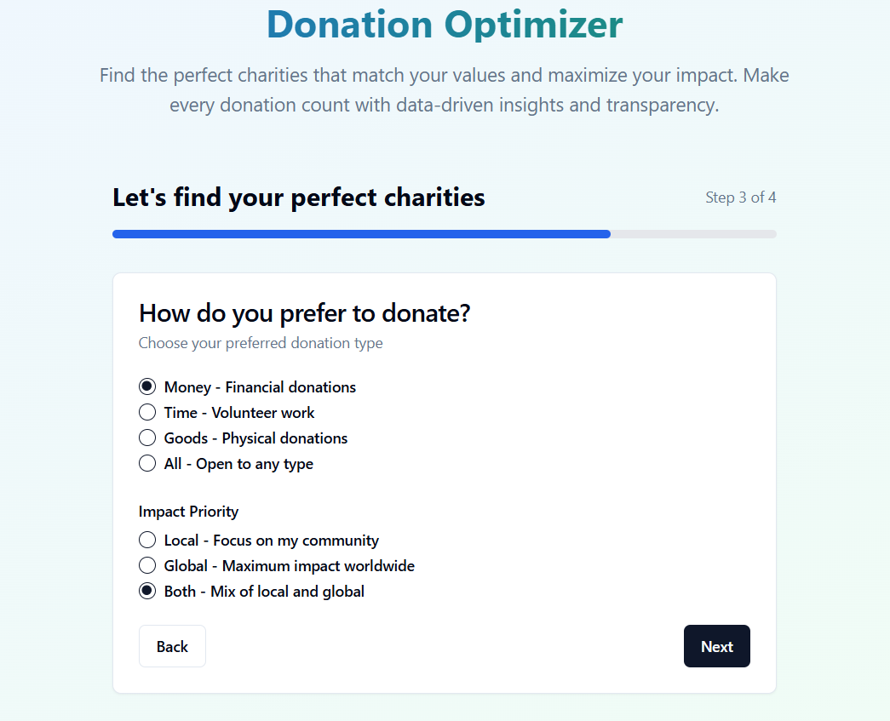

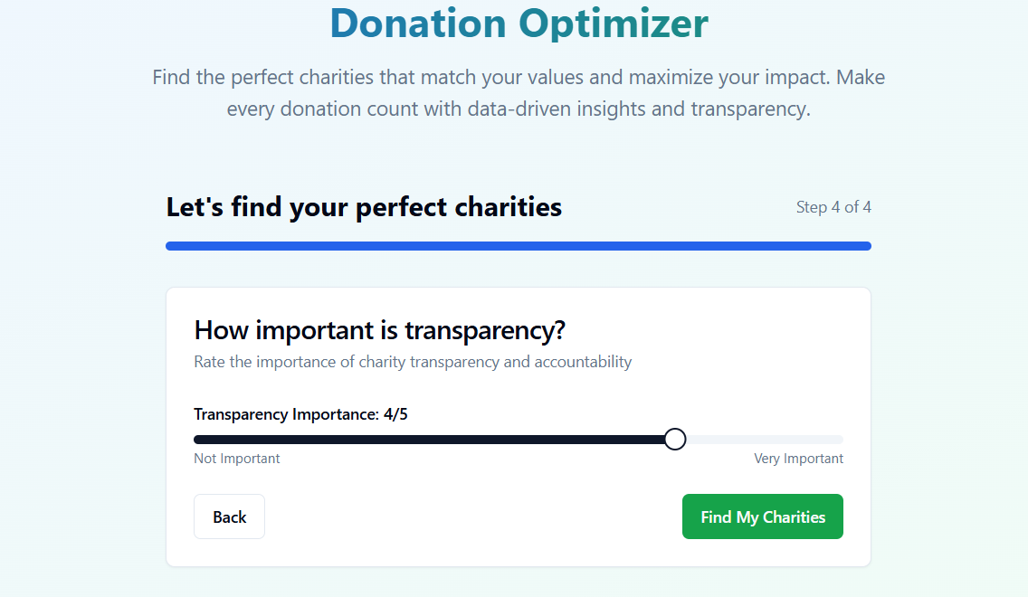

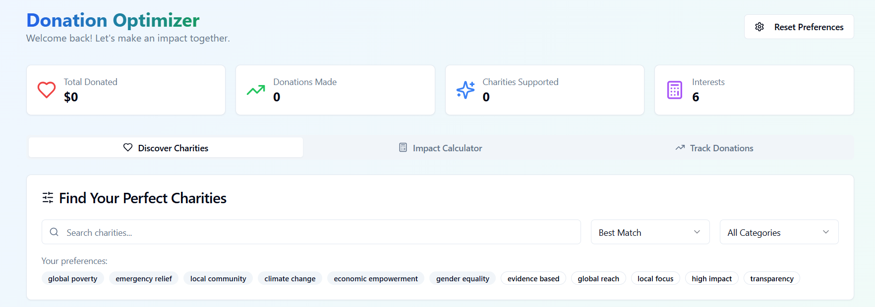

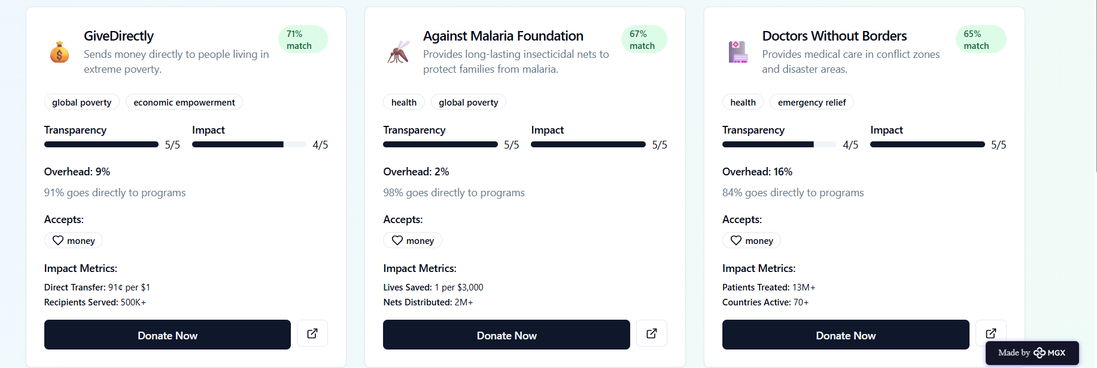

*Step 7: Test – Getting Feedback*

* Who did I share my solution with?

I shared my donation optimizer solution with:

I shared my Donation Optimizer solution with parents, teachers, and students to get feedback from different viewpoints. Since all of them could benefit from the tool in different ways, I wanted to understand their needs and preferences. Their input helped me identify what features would be most useful and how to make the tool simple and engaging. Hearing from these groups also showed me how important it is to build trust and make the donation process clear for everyone.

What feedback did I receive?

**Feedback: Pros and Cons**

**Pros (Positive Insights from Feedback):**

1. Helps donors make smarter, more impactful donations.
2. Builds trust by showing how money is used.
3. Encourages regular giving through goal setting and reminders.
4. Easy-to-use design makes it accessible for parents, teachers, and students.
5. Personalized suggestions make donating more meaningful.

**Cons (Areas to Improve Noted in Feedback):**

* May require users to input a lot of information initially.
* Some users might find tracking impact data overwhelming.
* Could be challenging to keep all charity information up to date.
* Users without tech skills might need extra help navigating.
* Dependence on internet and devices might limit access for some.

**My Response for The Feedback:**  
Thank you for the thoughtful feedback on the Donation Optimizer.  
As the developer, I truly appreciate insights that help improve both function and impact.  
Your suggestions are already being considered for upcoming updates.  
Optimizing for smarter giving is the goal—and your input brings us closer.  
Excited to keep refining and sharing progress soon

👍 What works well:

**What Works Well**

1. **Smart Matching:** Accurately connects donors to causes aligned with their values.
2. **Clean UI/UX:** Simple, intuitive design that users can navigate easily.
3. **Real-Time Impact Feedback:** Keeps users engaged and informed about their donation’s effect.
4. **Fast Performance:** Quick, reliable backend ensures smooth experience.
5. **Scalable System:** Built to grow and integrate with larger platforms.
6. **Positive User Response:** Early testers report high satisfaction and ease of use.

🔧 What needs improvement:

1. **1. Personalization Depth:** Refine user profiles to deliver smarter, more tailored cause recommendations.
2. **2. Data Quality:** Improve accuracy, reliability, and freshness of nonprofit and impact data.
3. **3. Mobile Optimization:** Enhance layout and interaction design for mobile and tablet users.
4. **4. Onboarding Flow:** Make the sign-up and first-use experience more intuitive and engaging.
5. **5. Impact Visualization:** Develop more dynamic, visual ways to show how donations make a difference.
6. **6. Accessibility:** Ensure the app is fully usable by people with disabilities (e.g., screen reader support).
7. **7. Gamification Features:** Introduce elements like streaks or badges to boost donor retention.
8. **8. Donation History:** Add a more detailed history section with export options for records or taxes.
9. **9. Localization:** Enable multi-language support for broader global accessibility.
10. **10. Community Features:** Create space for users to share causes, impact stories, or fundraising goals.

*AI Tools you can use for Step 6-7:*

**ChatGPT/Perplexity AI/Claude AI/Canva AI/Chatling AI/Figma AI/Metamgx/Gamma AI**: You can use these tools to build solutions/models or mock-up dummy prototypes

ggggg *AI Tools you can use for Step 6-7:*

**ChatGPT/Perplexity AI/Claude AI/Canva AI/Chatling AI/Figma AI/Metamgx/Gamma AI**: You can use these tools to build solutions/models or mock-up dummy prototypes

*AI Tools you can use for Step 6-7:*

**ChatGPT/Perplexity AI/Claude AI/Canva AI/Chatling AI/Figma AI/Metamgx/Gamma AI**: You can use these tools to build solutions/models or mock-up dummy prototypes

***Day 4: Showcase***

*Step 8: Presenting my Innovation:***Presenting My Innovation: Donation Optimizer**

The **Donation Optimizer** is a smart giving platform designed to help donors make impactful, data-driven decisions.  
It uses intelligent algorithms to **match users with causes** that align with their values and goals, while providing **real-time feedback** on the outcomes of their donations.

**🌟 Key Highlights:**

* **Smart Matching:** Aligns donations with user values and high-impact causes.
* **User-Friendly Design:** Simple, intuitive interface for effortless giving.
* **Real-Time Impact:** See where your money goes—and the difference it makes.
* **Scalable & Secure:** Built to grow, with performance and data integrity at its core.

**Impact:** **Donation Optimizer empowers donors to make smarter giving choices, maximizing the positive impact of every dollar. By connecting generosity with data-driven insights, it turns donations into real, measurable change for the causes that matter most.**

**<SHOWCASE YOUR INNOVATION TO YOUR PEERS>**

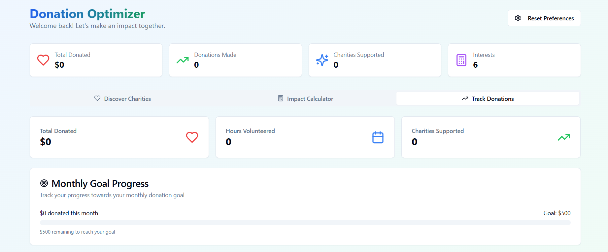

*Step 9: Reflections*

What did I enjoy the most during this project-based learning activity?

What I enjoyed most during this project was the chance to create something that can make a real difference. I loved diving into the challenge of optimizing donations and seeing how technology can help people give smarter and feel more connected to the causes they care about. It was rewarding to combine creativity, problem-solving, and impact all in one project.

What was my biggest challenge during this project-based learning activity?

My biggest challenge was balancing the technical complexity of building an effective optimization algorithm with creating a simple and user-friendly experience. It was tough to make sure the tool was both powerful and easy to use, but overcoming that pushed me to improve both my coding and design skills.

**Take-home task**

<https://github.com/punithhcreator/Careerpath-No-code-application>

*AI Tools you can use for Step 8:*

**Canva AI:** You can use this to design your pitch document. Download your pitch document as a PDF file and upload on GitHub